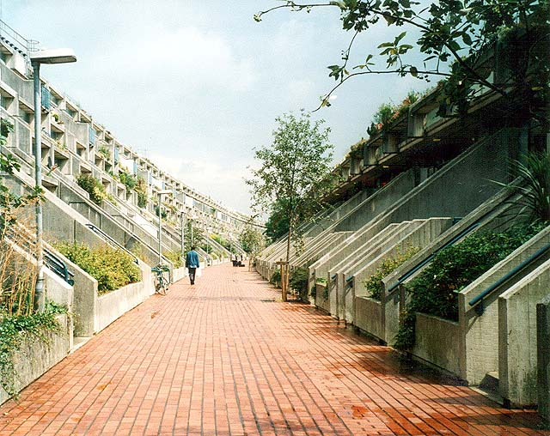

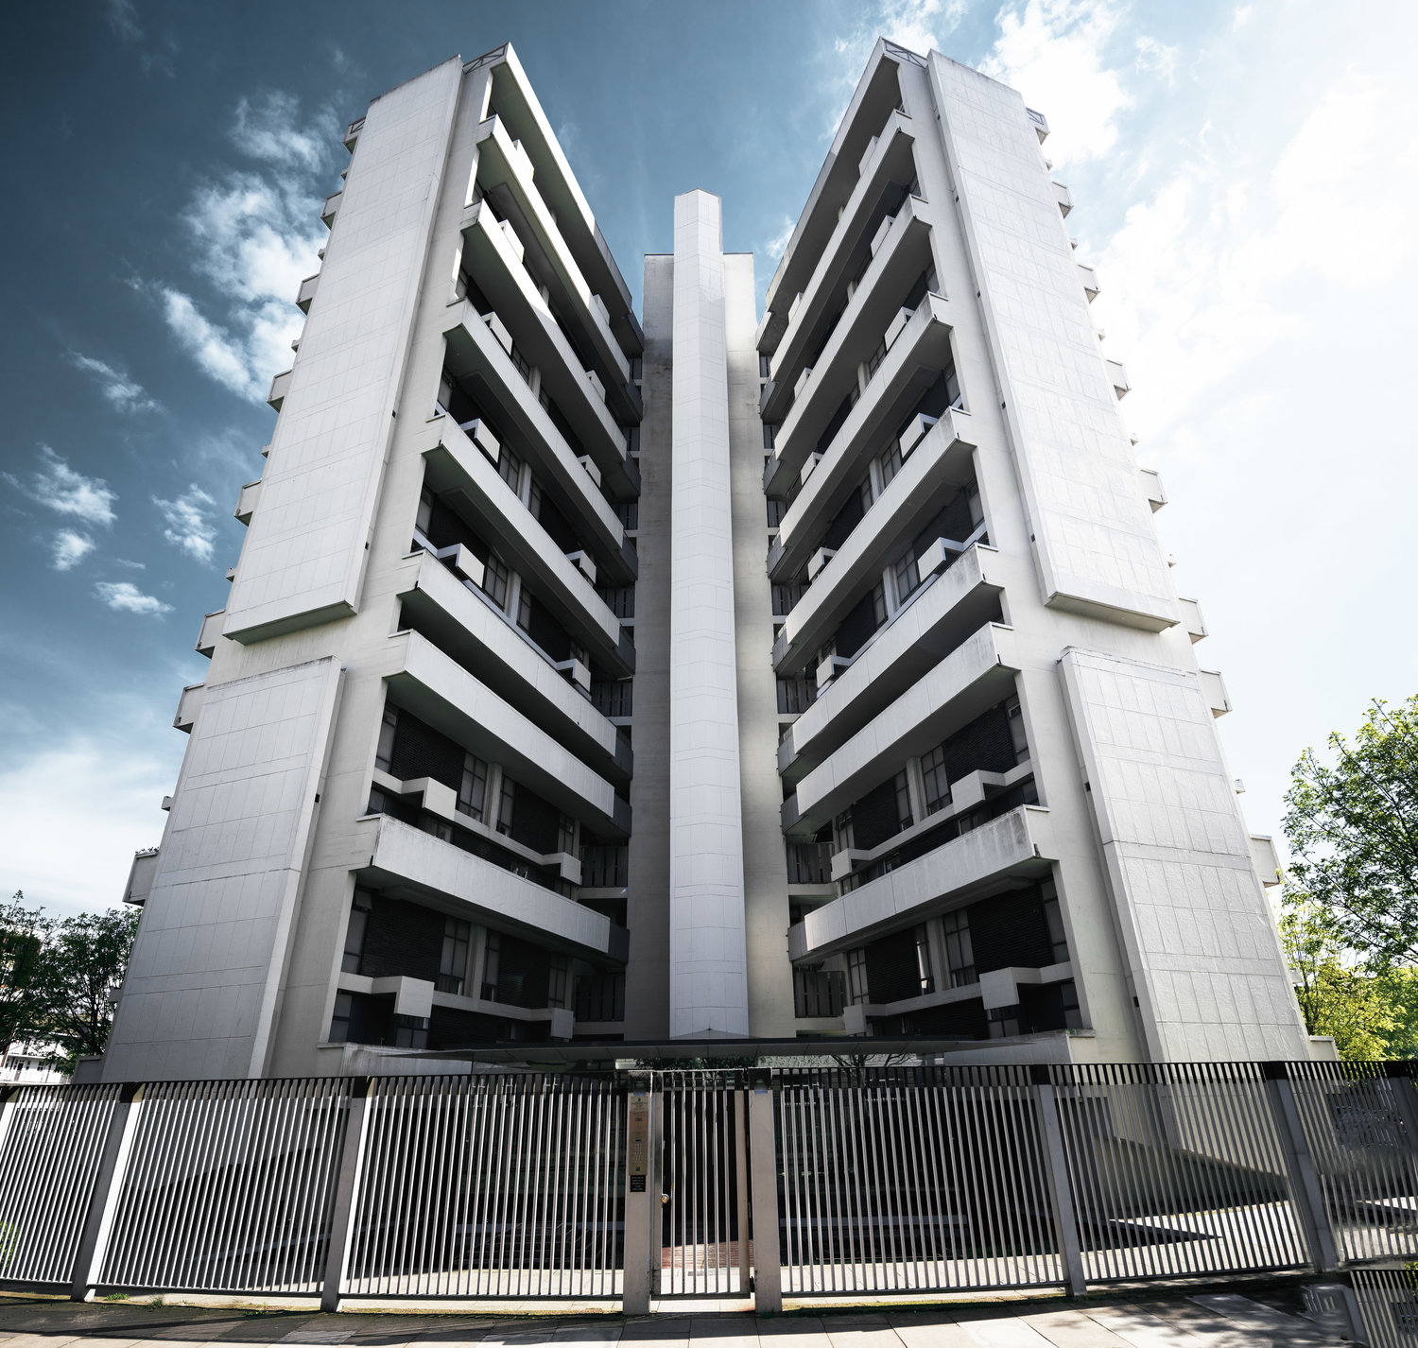

Fig.2 Denys Lasdun (1957) Keeling House. Overview: Cluster-block high-rise social housing block. [Photo: Tom Oliver Payne (2010s)]

Fig.1 Neave Brown (1968) Alexandra Road Estate. Overview: Low-rise high-density social housing estate. [Photo: S Williams (August 2002)]

‘An analysis of the shared communal spaces in Keeling House and Alexandra Road Estate’

Essay 2

The shared communal spaces in Keeling House and Alexandra Road had similar functional aims, but were designed with contrasting formal qualities from distinctive, pioneering approaches. Keeling House is a 16-storey social housing ‘cluster-block’ tower designed by Denys Lasdun in 1955, for the Borough Council of Bethnal Green in London. Lasdun’s experimental approach adapted conventional tower block design for a greater “sense of home”[1] for residents, imitating both the privacy and intimate communal space of the local Victorian terraces. Alexandra Road estate was designed by Neave Brown for Sydney Cook’s Camden Council Architect’s Department in 1968, to be a low-rise, high-density, “people focused domestic space”[2], consisting of three rows of apartments. This was radically different to Keeling House, in that Brown’s design dedicated much more of its footprint to the shared communal space; including a 4 acre community park in between the two pedestrianised ‘social streets’[3] that formed the communal hubs.

The shared spaces in each of these social housing solutions were effective in their own right, bringing in innovative techniques and exemplifying the capacity for subtle beauty in Brutalist architecture. In my view however, the true test of these buildings is whether they fulfil their function to create dynamic spaces for community interaction. Brown’s design realised its social aim in a more tangible manner, and in doing so built an ideological bastion for the collectivist principles behind quality socialised housing “on the very cusp of the change from socialism to the me-generation”[4].

Fig.4 Neave Brown. (1968) Alexandra Road. Unimposing high-rise design & geometric footpath design in the park. [Photo From alexandraandainsworth.org (1983)]

Fig.3 Denys Lasdun. (1957) Keeling House. Exterior angular concrete detailing. [Photo: From V&A (1959)]

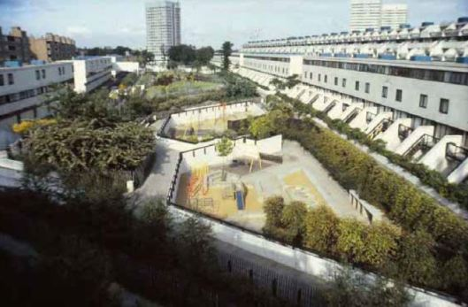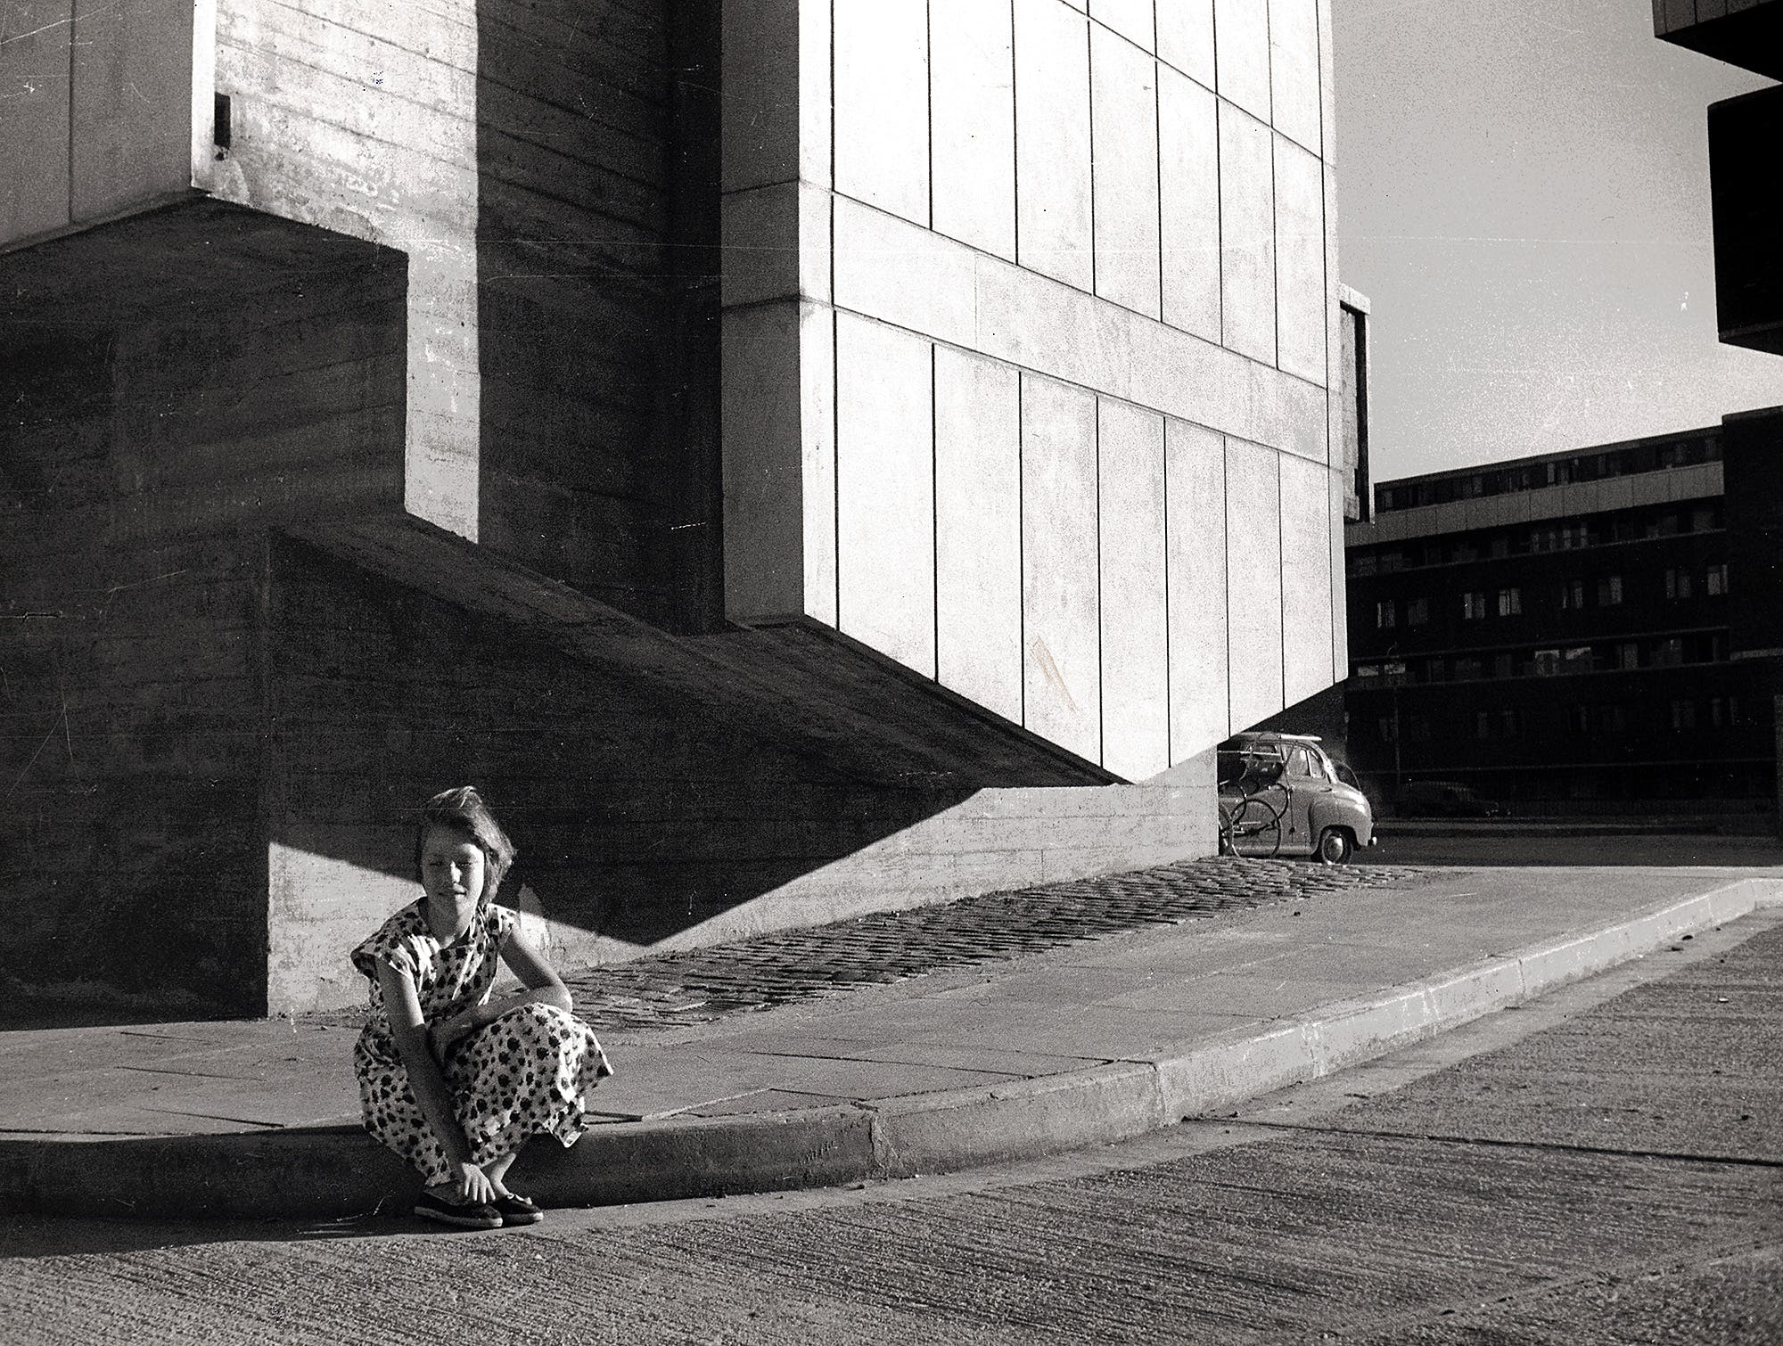

Fig.4 Denys Lasdun. (1957) Keeling House. Cluster-block design: floor plan for platforms connecting 4 apartments [Original Drawing: Lasdun Archive (RIBA)]

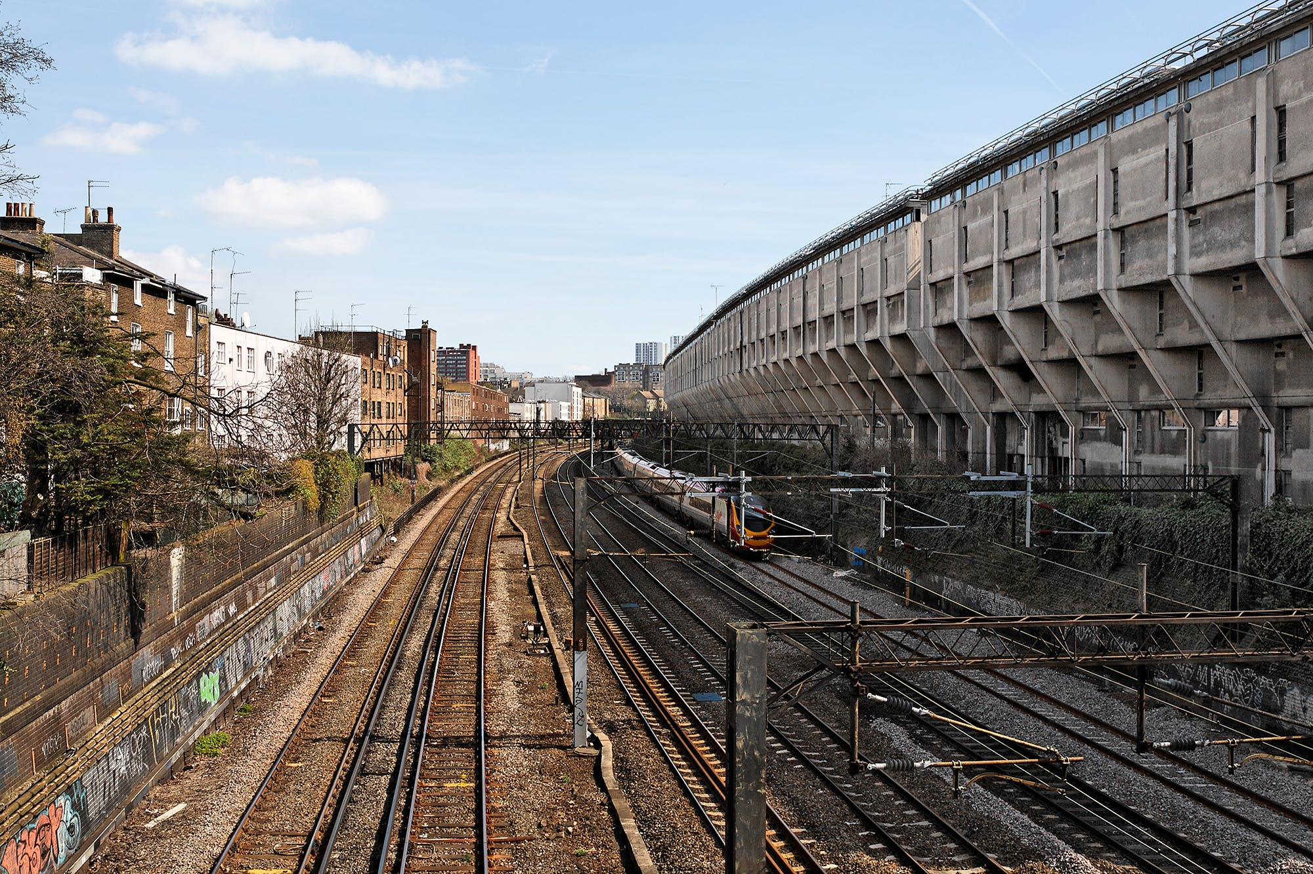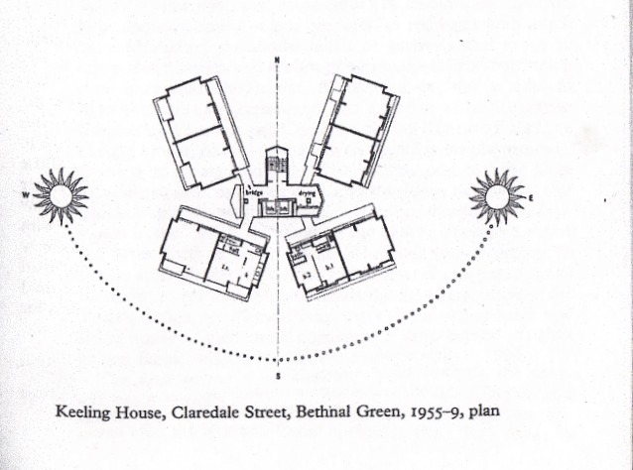

Fig.5 Neave Brown. (1968) Alexandra Road Estate. Ziggurat terrace design elevated at rear to reduce noise from passing trains [Photo: Eric Firley (2010)]

These two projects produced starkly different visual outcomes despite similar social aims founded in energetic Post-war Labour councils. The most obvious distinction is that Keeling House is a 16-storey high-rise tower, and therefore its social spaces are vertically organised in shared platforms connecting the maisonettes on each floor, whereas Alexandra Road’s communal space is arranged horizontally through 7-storeys of terraced apartments and a pedestrianised street. The difference in scale has significant implications for the socialising functionality of the designs, but looking at it purely visually, the comparably less imposing low-rise design conjures an image of leafy suburban tranquillity. Helped by the greenery crammed into each terrace box, this layout of Alexandra Road creates the more supportive social space of the two overtly Brutalist buildings. Although some Brutalist critics likens it to Alcatraz[5], the residents “overwhelmingly [describe it] as a friendly, neighbourly estate”[6] corroborating this positive evaluation of the space. The buildings’ Brutalist style included a purity of line which materialised the era’s modernist vision; both received Grade II listings in the 1990s in recognition of this feat. In particular, Keeling House’s subtle, external concrete angular detailing has been praised as “a building which takes the ‘brutal’ out of brutalism”[7], despite being called “ugly and bleak”[8] by some. I also find both designs to be visually dynamic for their age; Alexandra Road’s geometric walkway design in the park and the scaled-up terracing of maisonettes from Brown’s Bundoyne Road project (1975), are matched by the sky-bridges of Keeling House’s communal platforms.

Both architects brought technological innovation to their designs, including conceptual responses to the drawbacks of mixed development housing, and physical elements in the designs. For example, Lasdun’s Keeling House design was a theoretical reaction against Le Corbusier’s 1933 ‘Athens Charter’ and subsequent post-war, high-rise social housing in London, shown to lack the sense of belonging of previous housing styles[9]. The cluster-block technology used in Keeling House’s social spaces, bringing small groups of 4 apartments together, was a direct response to disparate communities in large scale blocks that Lasdun identified as the key problem with contemporary building orthodoxy. His social commitment to this aim for working-class tenants, produced the successful, small-scale neighbour interaction, attested to by residents: “there was only four people on each landing, you virtually knew everybody. It was nice.”[10] Practically, Alexandra Road’s ziggurat design, intentionally elevated at the rear, maximised terracing for communal space, but also reduced noise from trains on the Euston line behind to form a valuable community space where “children played on the car-free red brick road and in the park between the buildings”[11]. Conceptually, Brown was even more famous for

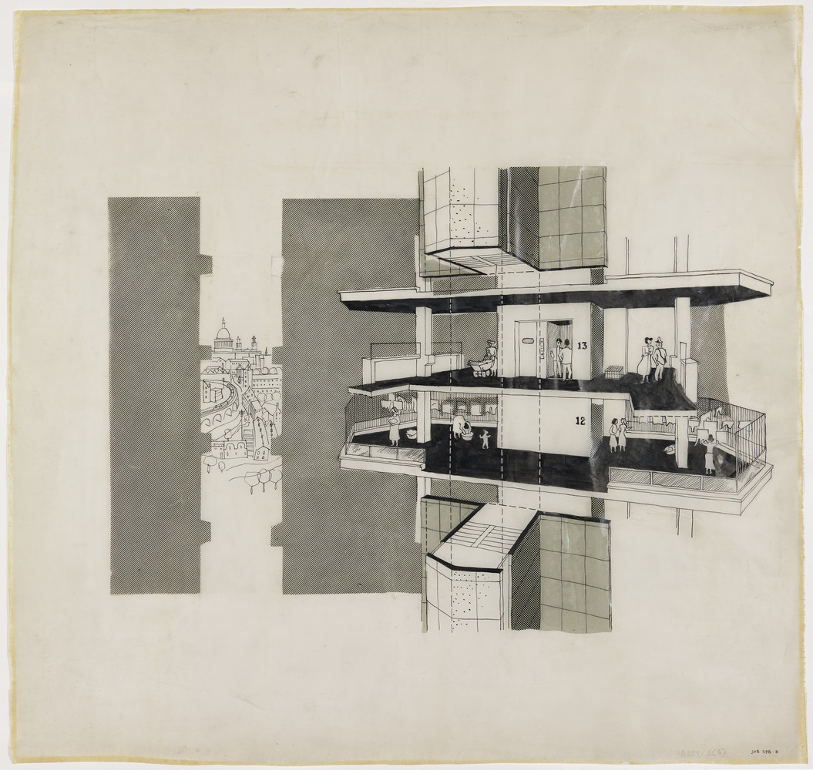

Fig.7 Neave Brown. Alexandra Road Estate. Communal areas: pedestrianised street and terraced balconies. [Photo: (from themodernhouse.com)]

Fig.6 Denys Lasdun. (1957) Keeling House. Small-scaled resident interaction on communal platforms. [Original Drawing: Lasdun Archive (RIBA)]

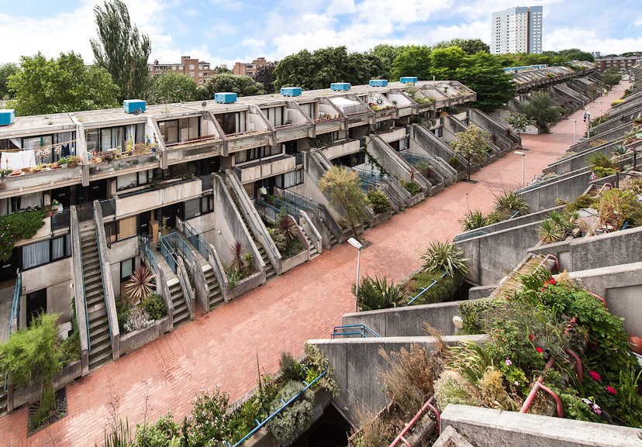

bucking building orthodoxy. In his partnership with Cook, he campaigned for low-rise solutions to high-density briefs[12], and at Alexandra Road achieved 210ppa, well above the 150ppa planners asked for. With this, “Brown proved… that low-rise housing could be delivered in the heart of a city at the density of a tower block but with the quality of public space that high-rise seldom attains”[13]. This was a major development in the building technology of the 1960s because Brown got low-rise recognised. This can be seen as a breakthrough for community interaction in mass social housing because low-rise with open spaces has been shown to be more effective than even Lasdun’s high-rise blocks.

These radical conceptual responses to building norms is why I find both of the buildings to be such successes in principle as well as practice. Their pursuit of functional aims for quality social spaces was born out of necessity; a practical need for more housing in post-Blitz London, the political need to fulfil Labour wartime promises to provide for the people, and the need to address the resident interaction shortcomings of previous high-rises[14]. Lasdun’s functional priority was to create small scale neighbourly interaction within a tower block. He drew influence from the communitarianism of the local Victorian terraces; as the Open University puts it, “Keeling House was an attempt to stand these streets on their ends.”[15] In conjunction with this, Lasdun aimed to create ‘human-scaled’ seclusion because locals told him “we’re not used to being in a great sort of huge block of one of thousands”[16]; Lasdun called it “a protest against treating the human being as a statistical pawn.”[17] This compromise between privacy and community was reached with the walkways only serving two flats and the blocks facing each other at oblique angles[18]. In my opinion, this was a valid approach since, even during the neglect of the 1980s, many tenants told Lasdun “we loved living in our crumbling tower block”[19]. However, Lasdun’s concentration on privacy and commitment to tower blocks not open low-rise, illustrates the greater success from Brown’s undistracted focus on community interaction.

Neave Brown (1929-2018) Architect of Alexandra Road Estate



Denys Lasdun (1914-2001) Architect of Keeling House

Looking back at these two buildings in today’s political climate, both designs symbolise the ideological hope of the 1960s because their high quality communal spaces are a physical embodiment of the period's communitarian dreams for working people. I believe that this legacy determines the success of the buildings, even above their visual contributions to the Brutalist style. Both structures were severely hit by the rate capping and right to buy schemes of the Thatcher government which reduced revenues for maintenance, and needed significant refurbishment by the late 1980s. Keeling House’s level of disrepair was such that it was sold off by Tower Hamlets in 1999. Once a bastion for modernism and quality social housing for the poor, it was engulfed by the market society it stood up to. Alexandra road however, remains a social housing estate that continues legitimise that ideological tradition. I don’t see Brown’s design as the more successful one just because it survived history. I find that his brave rejection of the conventional high-rise technique, not arbitrarily but for the social benefit of the people, sets his design above others. A commitment in Alexandra House to positive and open communal spaces proved to be highly effective in bringing the residents together, where Keeling House only managed such interaction on an isolated, smaller scale.

# Bibliography

1. Dreams, M. (2013, June 18th). The Alexandra Road Estate, Camden: 'a magical moment for British housing'. Retrieved from MunicipalDreams.wordpress.com: https://municipaldreams.wordpress.com/2013/06/18/the-alexandra-road-estate-camden-a-magical-moment-for-english-housing/
2. Dreams, M. (2014, February 25th). Keeling House, Bethanal Green: 'We loved living in our crumbling tower block'. Retrieved from Municipaldreams.wordpress.com: https://municipaldreams.wordpress.com/2014/02/25/keeling-house-bethnal-green/
3. Karakusevic, P. (2017). The Architect who reminds us council housing can be beatiful. The Guardian, [Online] Availible at https://www.theguardian.com/housing-network/2017/oct/20/neave-brown-architect-council-housing-beautiful-riba-gold-medal .
4. Kyriacou, L. (n.d.). Estate History: A short history of the Alexandra and Ainsworth Estate. Retrieved from alexandraandainsworth.org: http://alexandraandainsworth.org/estate-history-3
5. London Gardens Online. (2018, April 2nd). Alexandra Road Estate. Retrieved from londongardensonline.org.uk: http://www.londongardensonline.org.uk/gardens-online-record.php?ID=CAM001
6. Manchester History. (n.d.). Keeling House, Bethnal Green, London. Retrieved from manchesterhistory.net: http://manchesterhistory.net/architecture/1940/keelinghouse.html
7. Swenarton, M. (2017). Cook's Camden: Making of Modern Housing. London: Lund Humphreys Publishers.
8. Testado, J. (2016, November). RIBA and V&A's upcoming “A Home for All​” exhibition revisits six experimental social housing designs. Retrieved from archinet.com: https://archinect.com/news/bustler/6963/riba-and-v-a-s-upcoming-a-home-for-all-exhibition-revisits-six-experimental-social-housing-designs
9. The Open University. (2001, November 26th). Keeling House. Retrieved from Open.edu: https://www.open.edu/openlearn/history-the-arts/history/heritage/keeling-house
10. Victoria and Albert Museum. (2018, February 5th). (Captions from) A Home for all: six experiments in social housing. Architecture exhibition. London, UK.
11. Video: Keeling House Topping Out London 1958. (2010, November 11th). Retrieved from YouTube: https://youtu.be/xlocdOp6ZN0
12. Walsh, N. P. (2018, November 15th). 6 Radical Experiments in Social Housing Exhibited by the RIBA and V&A. Retrieved from Archdaily.com: https://www.archdaily.com/905948/6-radical-experiments-in-social-housing-exhibited-by-the-riba-and-v-and-a

1. Municipal Dreams. (2014). Keeling House, Bethnal Green: ‘We loved living in our crumbling tower block’ [Quoting Lasdun in John R Gold. (2007). The Practice of Modernism: Modern Architects and Urban Transformation, 1954–1972] <https://municipaldreams.wordpress.com/2014/02/25/keeling-house-bethnal-green/> [Accessed on 10th February 2019]
2. Paul Karakusevic. ‘The Architect who reminds us council housing can be beautiful’. The Guardian (20th October 2017). Available at <https://www.theguardian.com/housing-network/2017/oct/20/neave-brown-architect-council-housing-beautiful-riba-gold-medal> [Accessed on 10th February 2019]
3. Niall Patrick Walsh. (2018). 6 Radical Experiments in Social Housing Exhibited by the RIBA and V&A. [Quoting the RIBA and V&A exhibition captions (2018)] <https://www.archdaily.com/905948/6-radical-experiments-in-social-housing-exhibited-by-the-riba-and-v-and-a> [Accessed on 7th February 2019]
4. Municipal Dreams. (2013). The Alexandra Road Estate, Camden: ‘a magical moment for British housing’. [Quoting Martin Pawley. ‘Living on the Edge of Time’. The Guardian, 2nd April 1990] <https://municipaldreams.wordpress.com/2013/06/18/the-alexandra-road-estate-camden-a-magical-moment-for-english-housing/> [Accessed on 10th February 2019]
5. Municipal Dreams. (2013). The Alexandra Road Estate, Camden: ‘a magical moment for British housing’.
6. Municipal Dreams. (2013). The Alexandra Road Estate, Camden: ‘a magical moment for British housing’.
7. Municipal Dreams. (2014). Keeling House, Bethnal Green: ‘We loved living in our crumbling tower block’.
8. Municipal Dreams. (2014). Keeling House, Bethnal Green: ‘We loved living in our crumbling tower block’. [Quoted in Patrick Kelly. ‘Listing the Unloved’. Inside Housing (19 January 1993)]
9. The Open University. (2001). Keeling House. <https://www.open.edu/openlearn/history-the-arts/history/heritage/keeling-house> [Accessed 10th February 2019]
10. V&A. (2018). Exhibition: A home for all: six experiments in social housing. [Exhibition caption quoting Rose McCarthy (1992) a resident of Keeling House for 13 years] [Visited on 5th February 2019]
11. V&A. (2018). Exhibition: A home for all: six experiments in social housing. [Exhibition caption quoting Elizabeth Knowles (2017) a resident of Alexandra Road for 40 years] [Visited on 5th February 2019]
12. Mark Swenarton. (2017). Cook’s Camden: Making of Modern Housing. London: Lund Humphreys Publishers. Introduction.
13. Lefkos Kyriacou. A short history of the Alexandra and Ainsworth Estate. <http://alexandraandainsworth.org/estate-history-3> [Accessed 10th February 2019]
14. Municipal Dreams. (2014). Keeling House, Bethnal Green: ‘We loved living in our crumbling tower block’.
15. The Open University. (2001). Keeling House.
16. Municipal Dreams. (2014). Keeling House, Bethnal Green: ‘We loved living in our crumbling tower block’. [Quoting Lasdun in John R Gold. (2007). The Practice of Modernism: Modern Architects and Urban Transformation, 1954–1972]
17. V&A. (2018). Exhibition: A home for all: six experiments in social housing. [Exhibition caption quoting Denys Lasdun (1968) the architect of Keeling House]
18. V&A. (2018). Exhibition: A home for all: six experiments in social housing. [Exhibition Keeling House project summary text]
19. Municipal Dreams. (2014). Keeling House, Bethnal Green: ‘We loved living in our crumbling tower block’.